LEXINGTON Intense Net Sofa

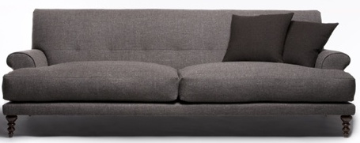

|  |
| --- |
| **DESCRIPTION** |
| Intense Net Sofa produced by LEXINGTON Sofa, presents a black pitched very comfortable sofa. The extra-long back relaxes the spinal cord extra long legs on bottom provide stability for the sofa. Available in Black bulky form and hand stitched cloth, the Delmard air filled leather with thick form will add comfort and class to the drawing room. |

|  |  |  |
| --- | --- | --- |
| **Price** | **3900$** | |
| **Dimensions** | **H** x **W** x **L** | **35in x 32in x 64in** |
| **Features** | **This Sofa is Build for two but four people can sit at once.** | |
| **Finished** | **Smooth Cloth Run** | |
| **Available in** | **Black and Grey** | |